Some prayer texts for November:

Sample Prayer of the Faithful
Priest celebrant: Confident that God hears the voices of those who trust in the Lord Jesus, we join our prayer to his.
Reader:
We pray that our departed sisters and brothers in our families and in our parishes, and all who have died in the past year, may be granted everlasting peace and rest. Lord, hear us. Lord, graciously hear us.
We pray for consolation for all who are grieving. Heal their pain, strengthen their hope, and comfort their hearts. Lord, hear us. Lord, graciously hear us.
We pray for all who are anxious, afraid, or lonely. May we be attentive to their needs and may all find courage, support and hope through the care of others. Lord, hear us. Lord, graciously hear us.
We pray for peace in our troubled world, for those suffering the ravages of war and displacement, for those in war torn areas living in fear of death, and for those grieving the death of loved children and family members. Lord, hear us. Lord, graciously hear us.
We pray that all in need may be graced with peace, justice and compassion; for all who bear the burden of poverty and homelessness, of loss of work, for the sick and all who are distressed in any way. Lord, hear us. Lord, graciously hear us.
Priest celebrant: Almighty and gracious God, our refuge and our strength, grant to all, living and dead, the fullness of your peace that you alone can give. Through Christ our Lord.

A Word of comfort in times of mourning…
St Paul wrote, nothing can separate us from the love of Christ,
so when I feel as though everything is falling apart because of the rawness of grief, or I feel guilty because I didn’t remember them today,
or I wonder: what will happen to all those precious memories when I forget? I can trust that in Jesus all will be well.
I can trust that I am forever wrapped in the love of God.
And I can trust that this love, which overcomes all things and endures all things, will hold me together, will hold us together today and always.
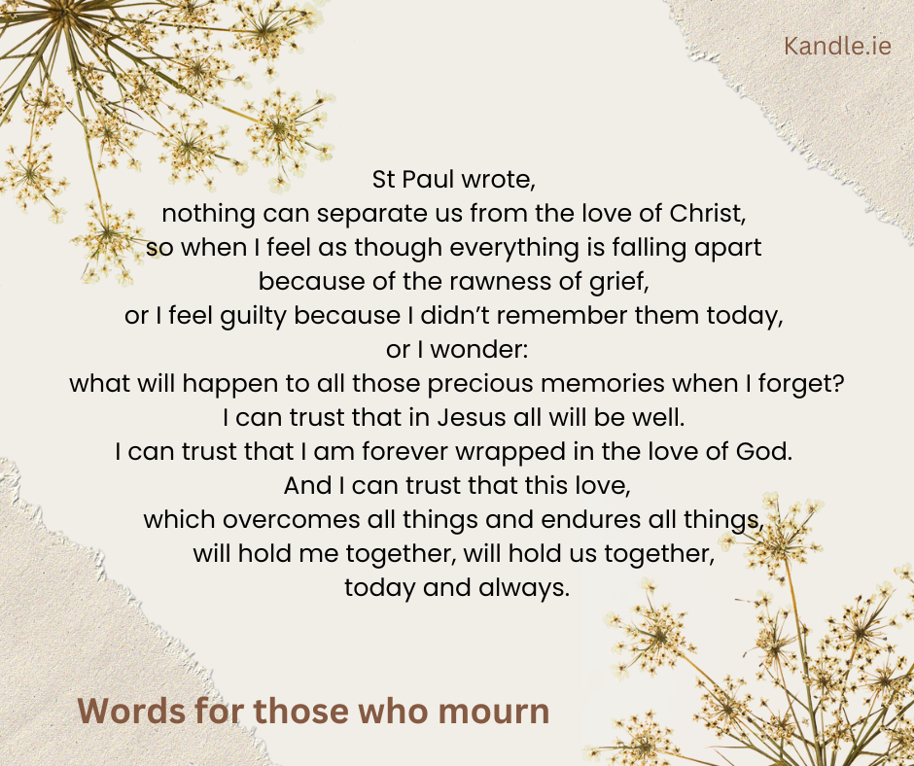

Solemn Blessing
From Roman Missal: In Celebrations for the Dead, p.560

May the God of all consolation bless you,
for in his unfathomable goodness he created the human race,
and in the Resurrection of his Only Begotten Son
he has given believers the hope of rising again. R. Amen.

To us who are alive, may God grant pardon for our sins,
and to all the dead, a place of light and peace. R. Amen.

So may we all live happily for ever with Christ,
whom we believe truly rose from the dead. R. Amen.

And may the blessing of almighty God,
The Father, and the Son, and the Holy Spirit,
Come down on you and remain with you for ever. R. Amen.

Bethany Bereavement Support Resources

On this website you can find the texts of a selection of prayers for the bereaved in different circumstances here:
https://www.bethany.ie/pages/prayers2.htm

The same prayers are given as prayer card images that parishes might like to use on social media or on parish newsletters
https://www.bethany.ie/pages/prayers2a.htm

Here is a sample of one of the prayers:
Prayer in Time Of Bereavement
Lord, you are close to the broken hearted
Be with me now in my grief and loneliness.
Give me the courage to face my loss and not to grieve in silence
Be with me as I struggle with many different and painful feelings.
Ease the hurt in my heart.
Encircle me in your love
Help me to believe that one day I will no longer have this deep sorrow
May I find comfort in sharing my grief,
With those who understand the strong bonds of love
Stay with me Lord, support me.
Help me to know that your power is at work within me as I deal with my grief.
Amen Sr Sheila McCauliffe RSCJ

